1 Niko Log In
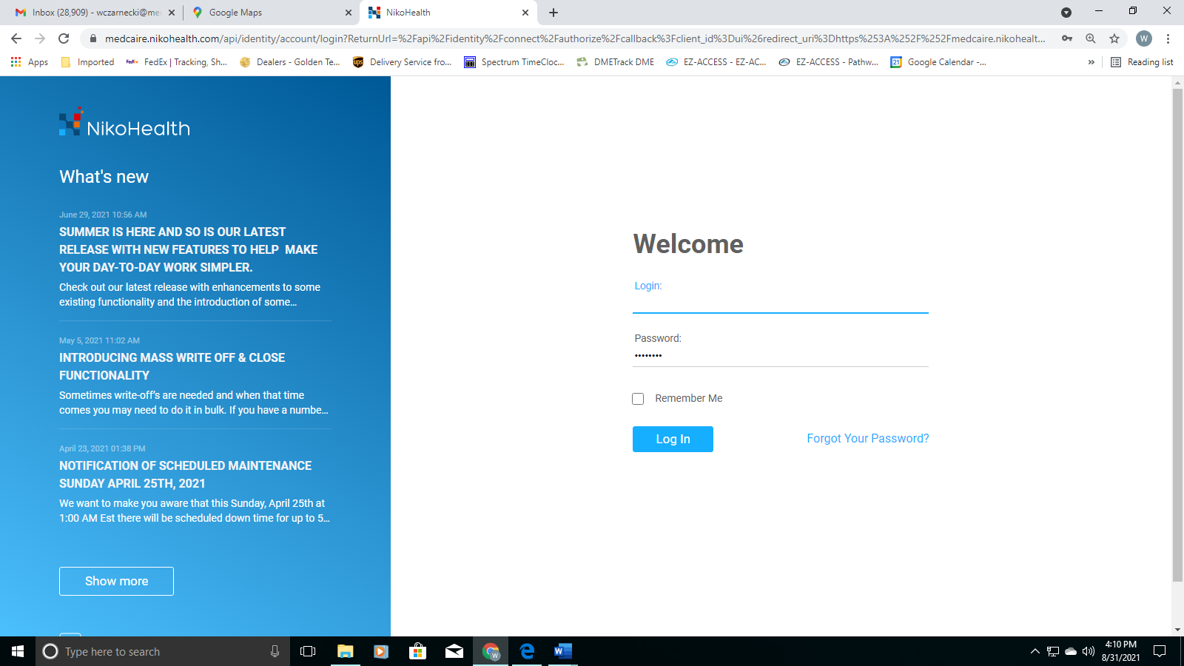

2 Select “Patient” from the Blue Menu Bar
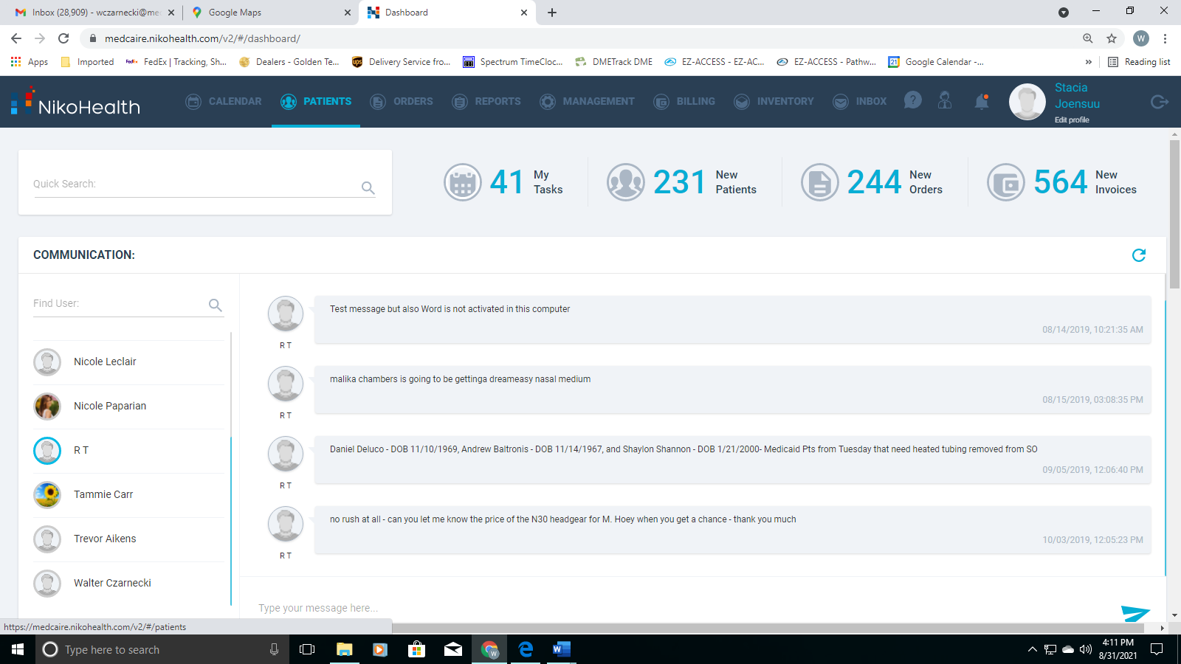

3 Enter Patient's name in the search field and select the patient file
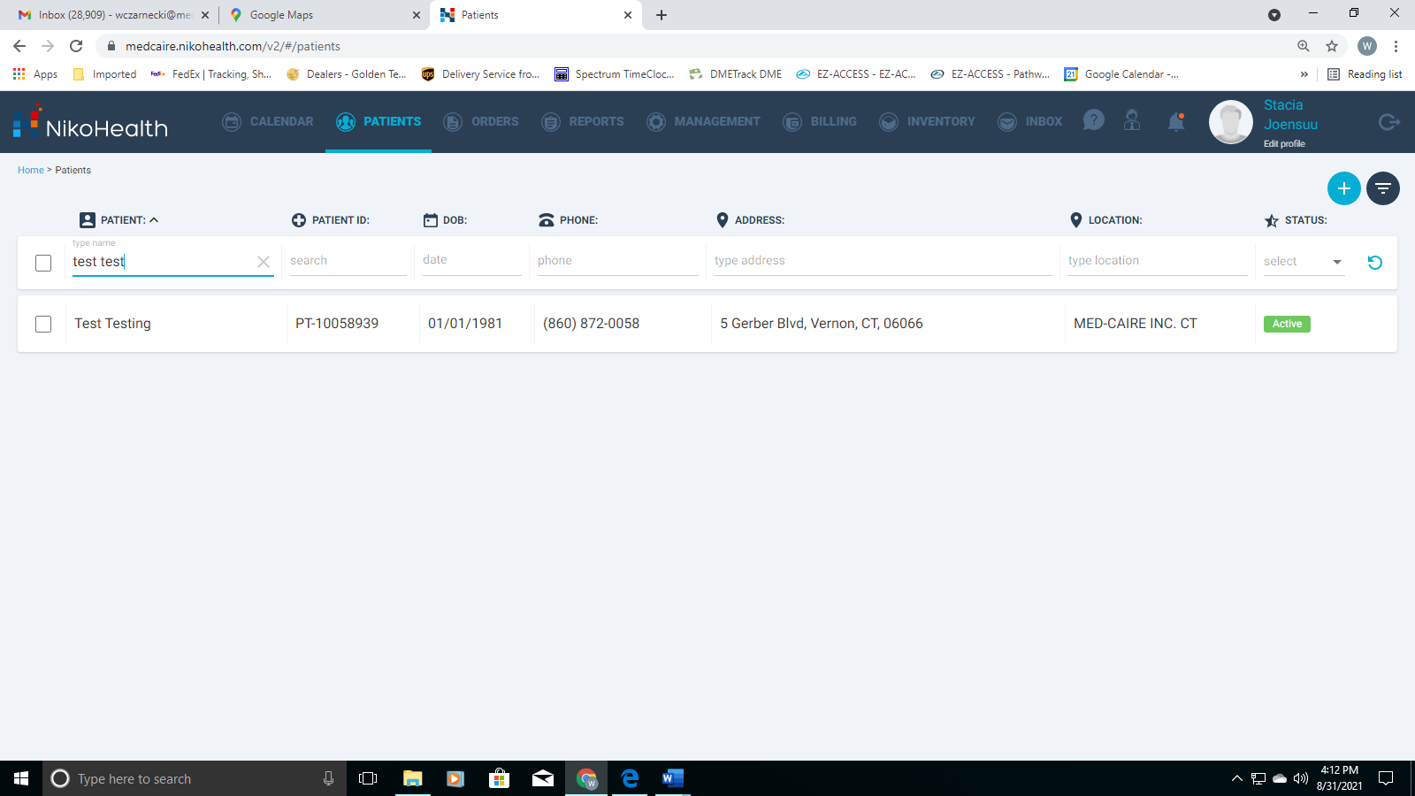

4 Select the "Note" Field in the grey menu bar (Highlighted in blue)
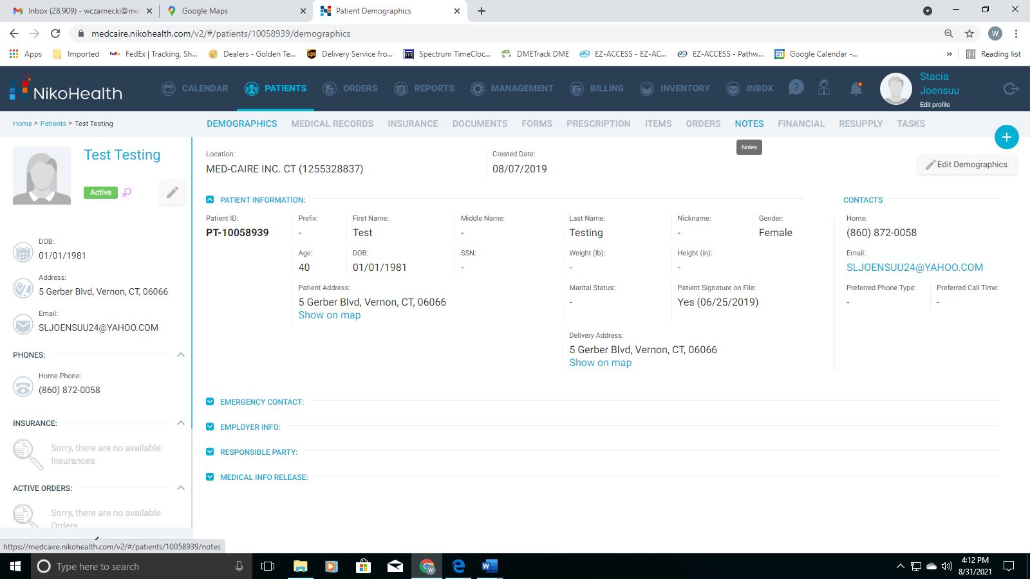

5 Use the drop down labeled "Select Subject", This is the reason for your note.
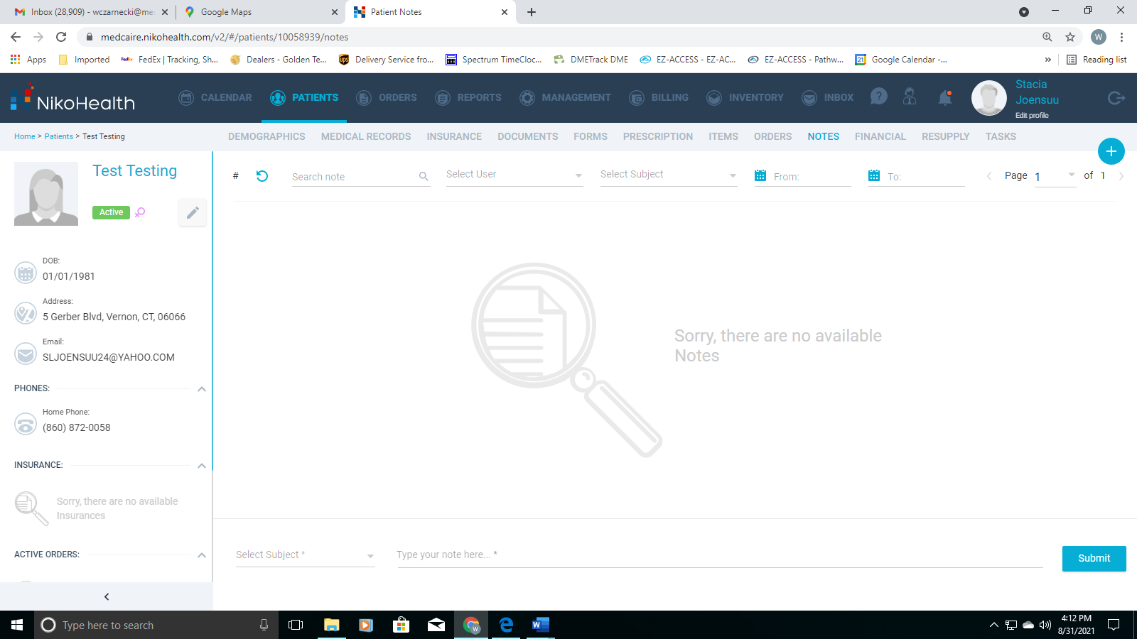

6 Choose your appropriate subject for the note your entering. If you’re not sure select “Other”
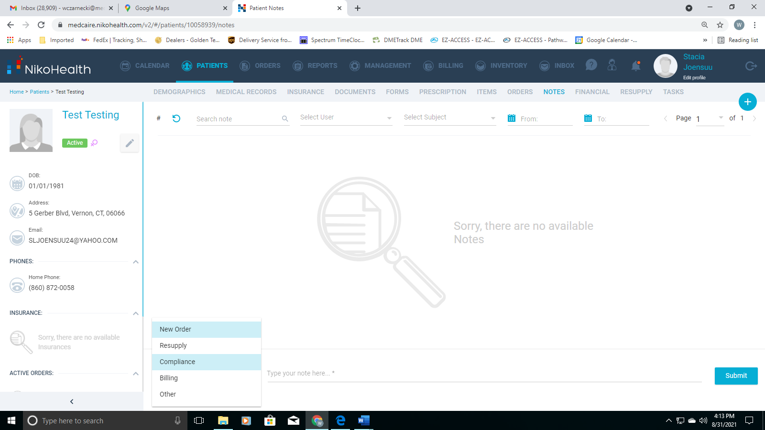

7 Create your note
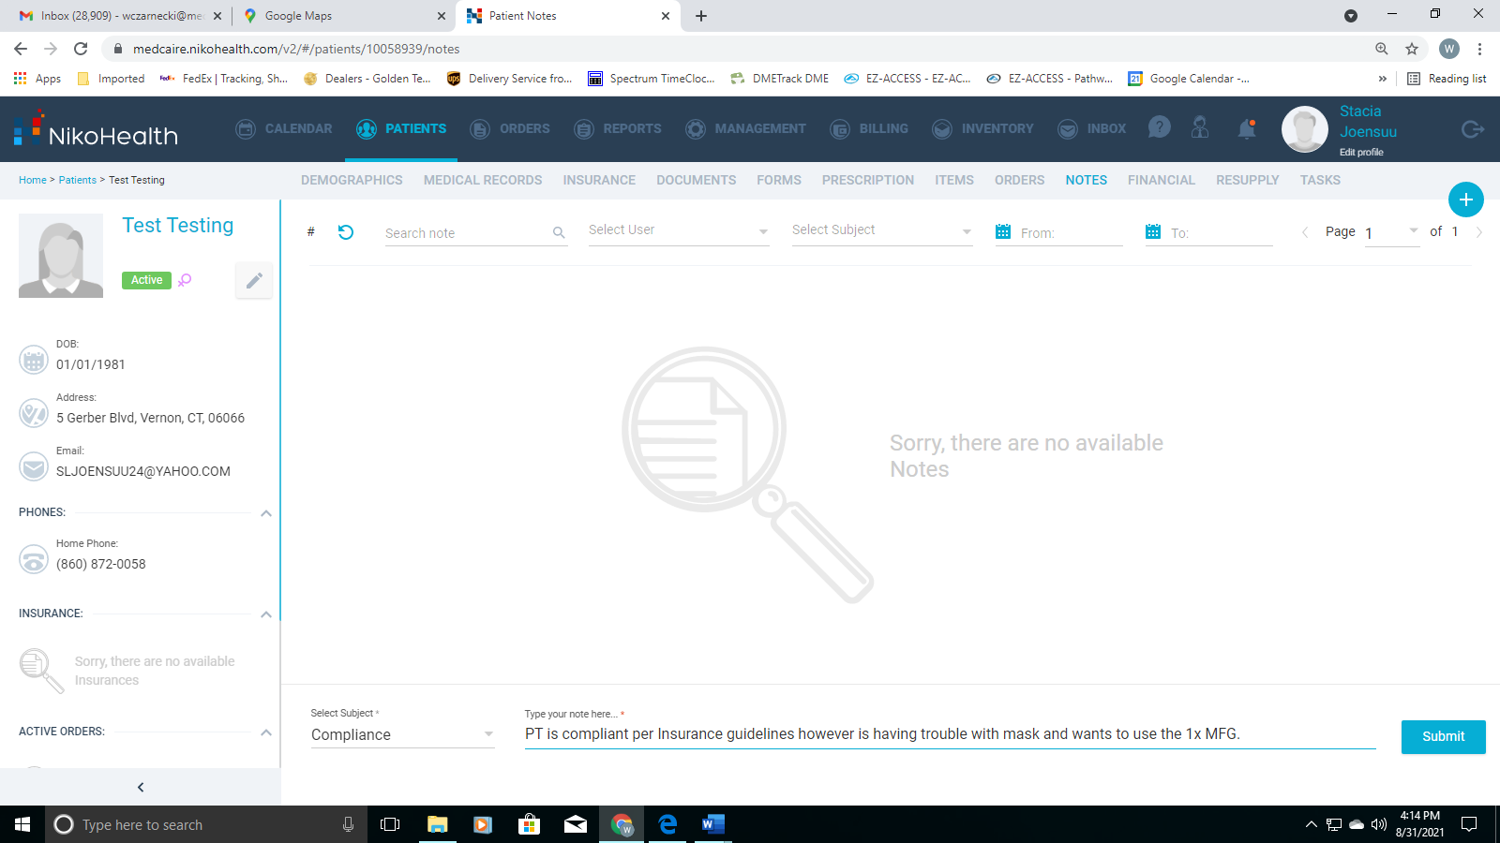

8 Select the blue "Submit" button so the note is saved to the patient's file
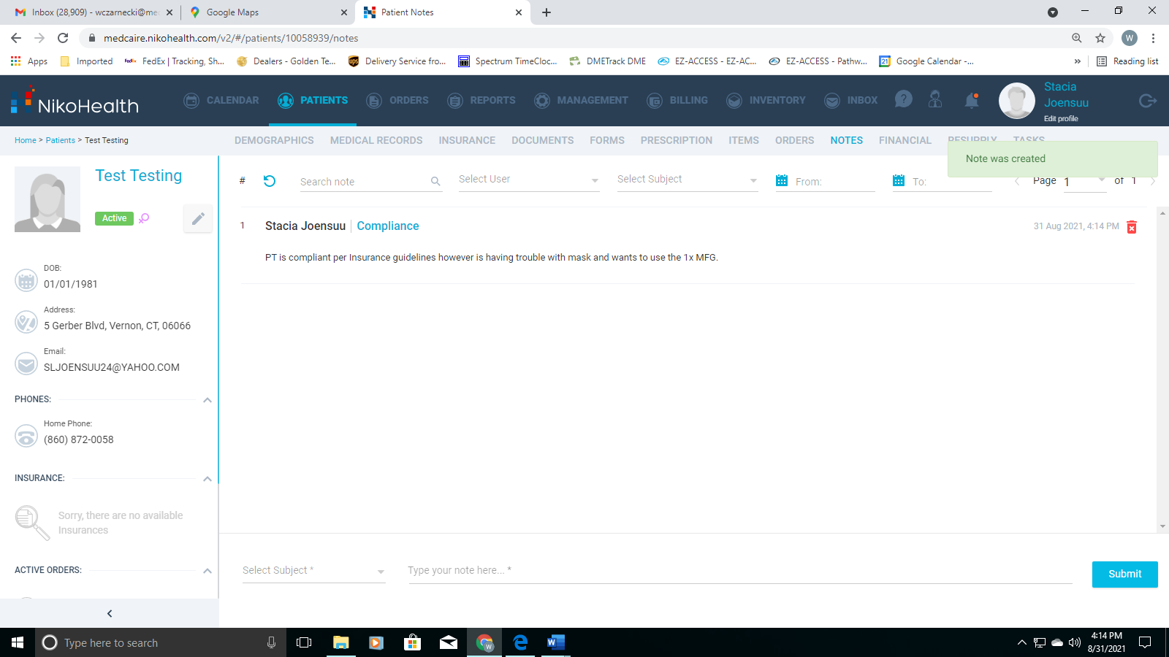

You should see your note in the patient’s file and your done.

