1- Select the Patient Tab and enter the patient's name you want to create a task for. Select the patient to enter the “Patient File”.
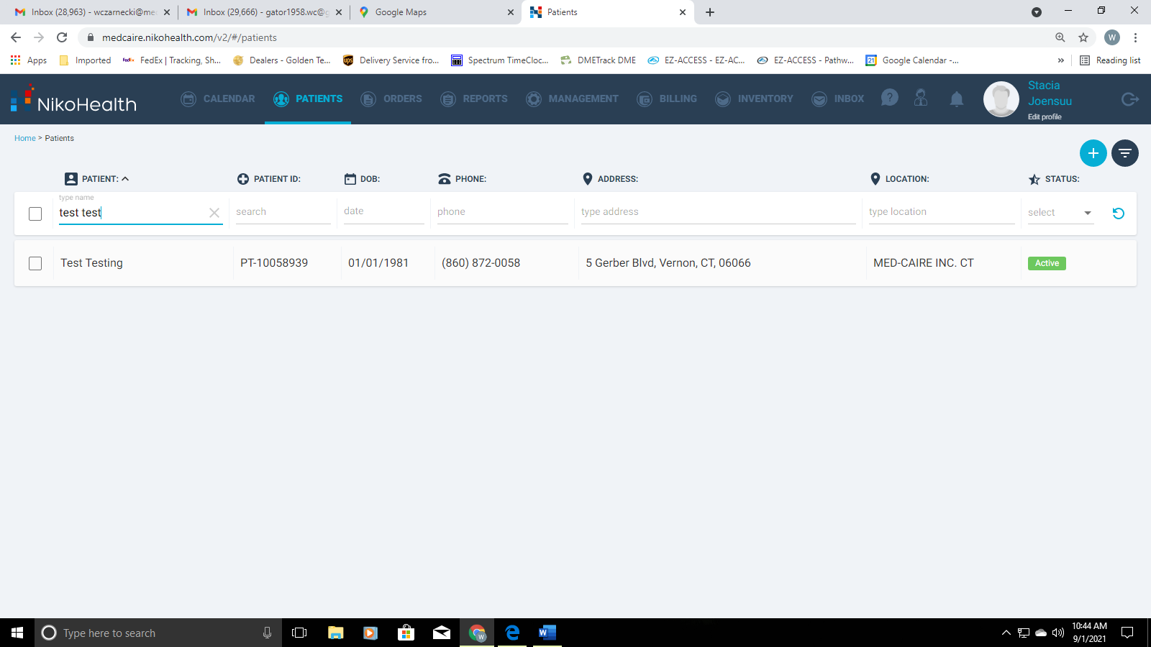

2- Select the tab labeled "TASKS" on the top "light grey menu bar"
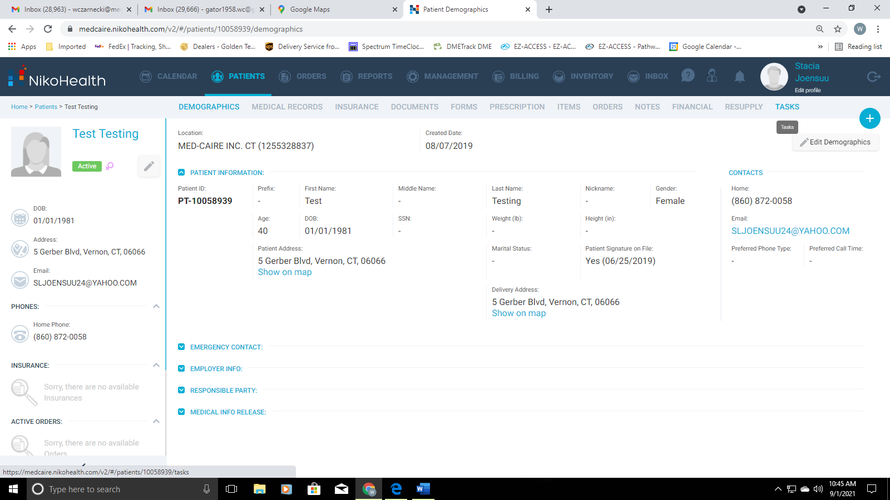

3- Use the “Blue Plus sign” on the Top Right of the patient file to create a new task
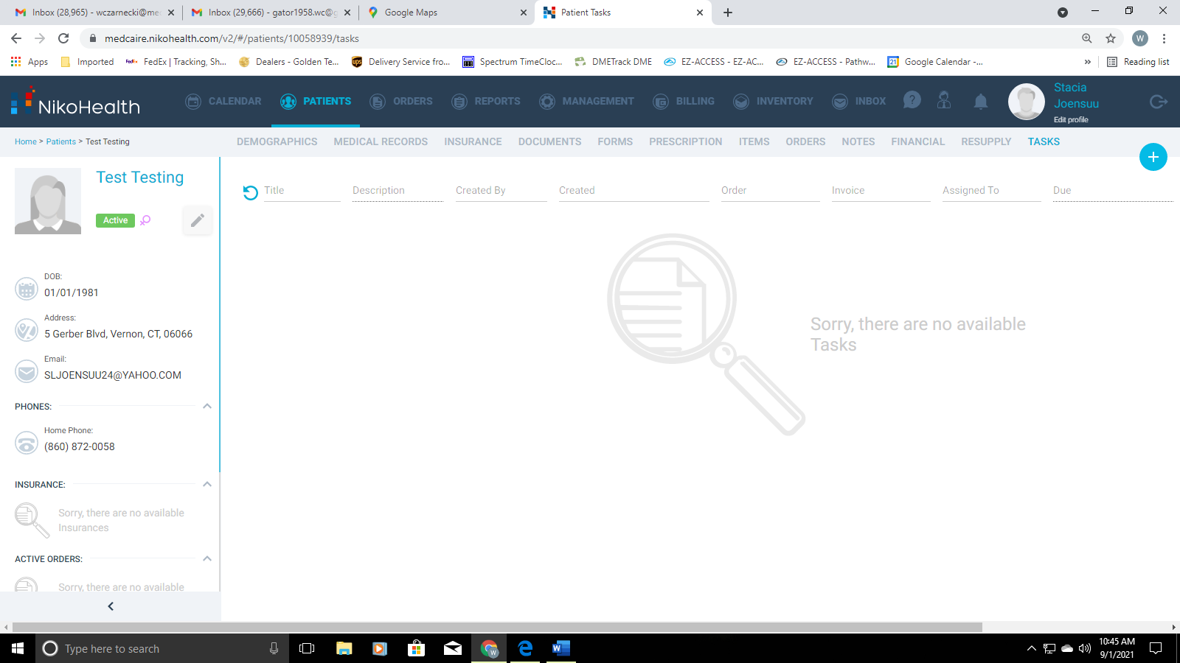

4- Select "Create Task" from the drop-down menu
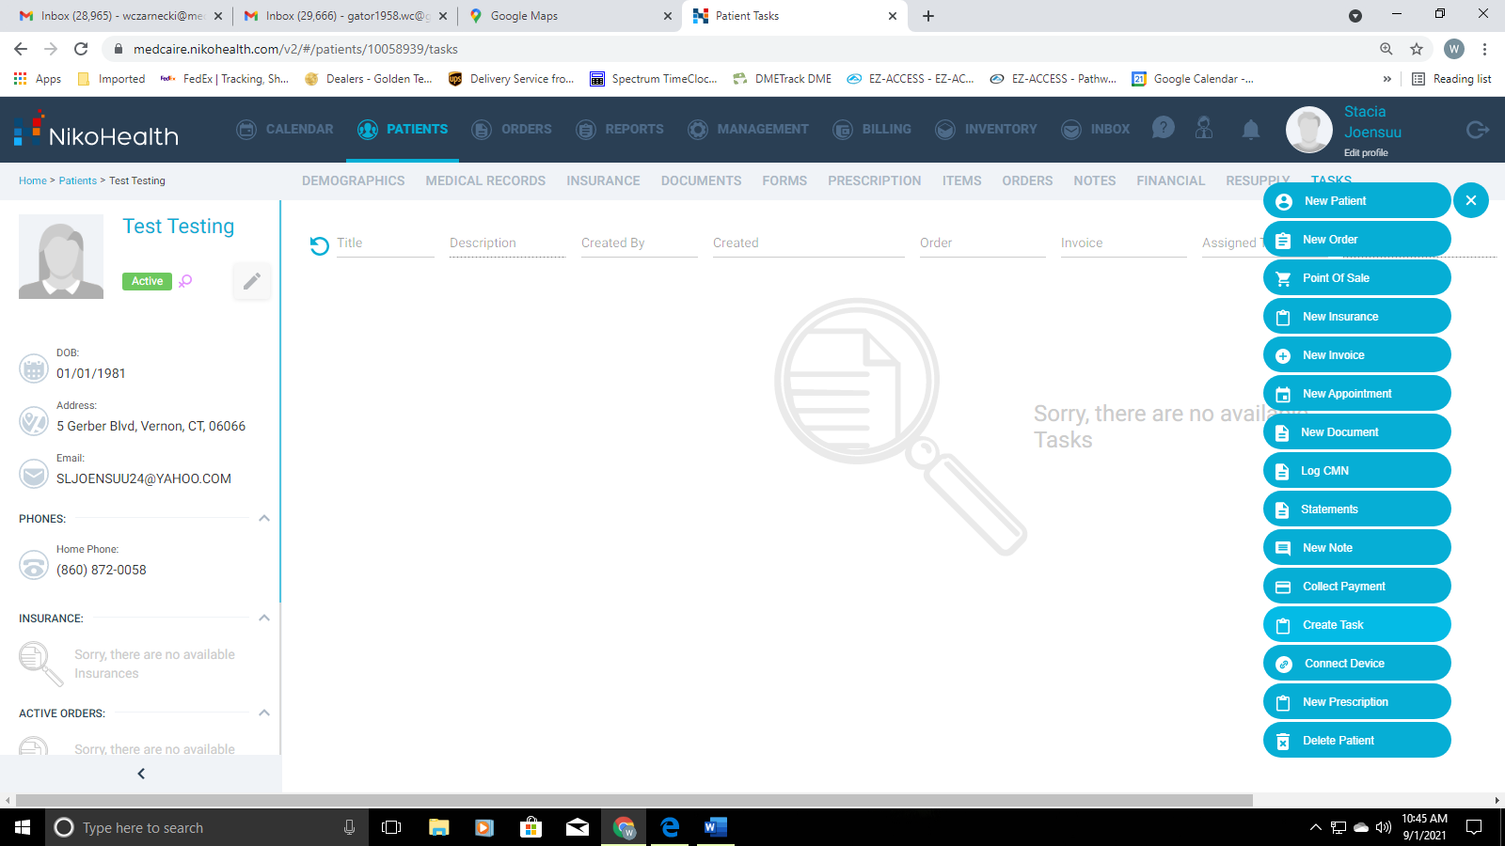

5- Fill in the "Title" (The reason for the task). Fill in the “Description” of the task needed. The patient will already be assigned to the task
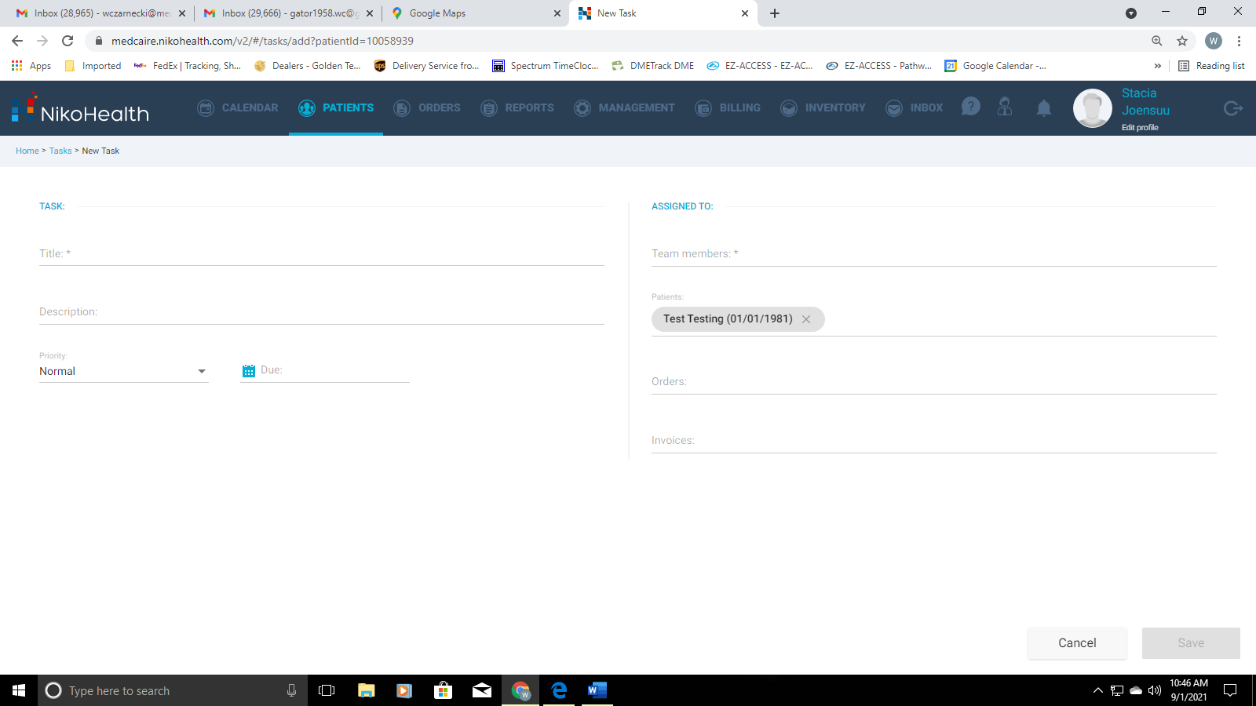

6- Select the appropriate Task "Priority" from the drop down. Select the "Date" the task is due to be completed on and assign the “Team Member” that the task is for (This can be multiple users).
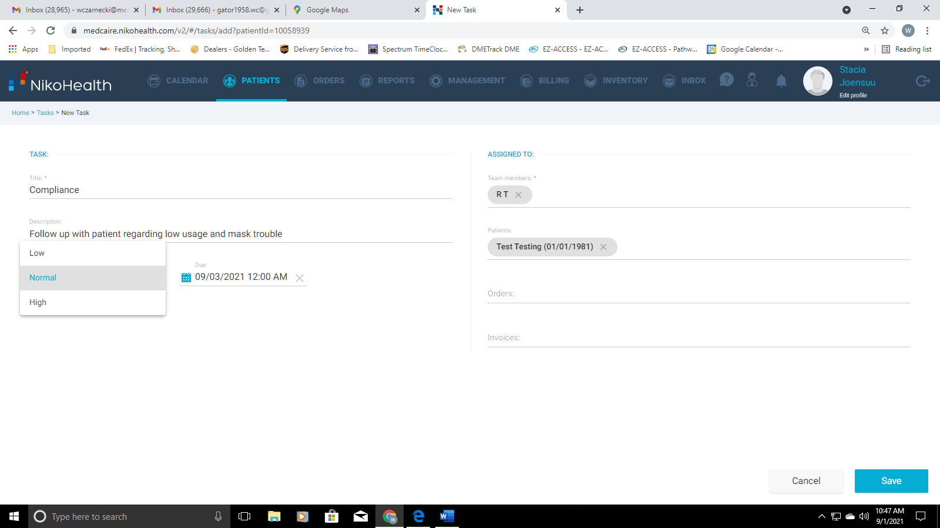

7- Once All necessary fields are completed, Save the task using the "Blue" Save button at the bottom right corner.
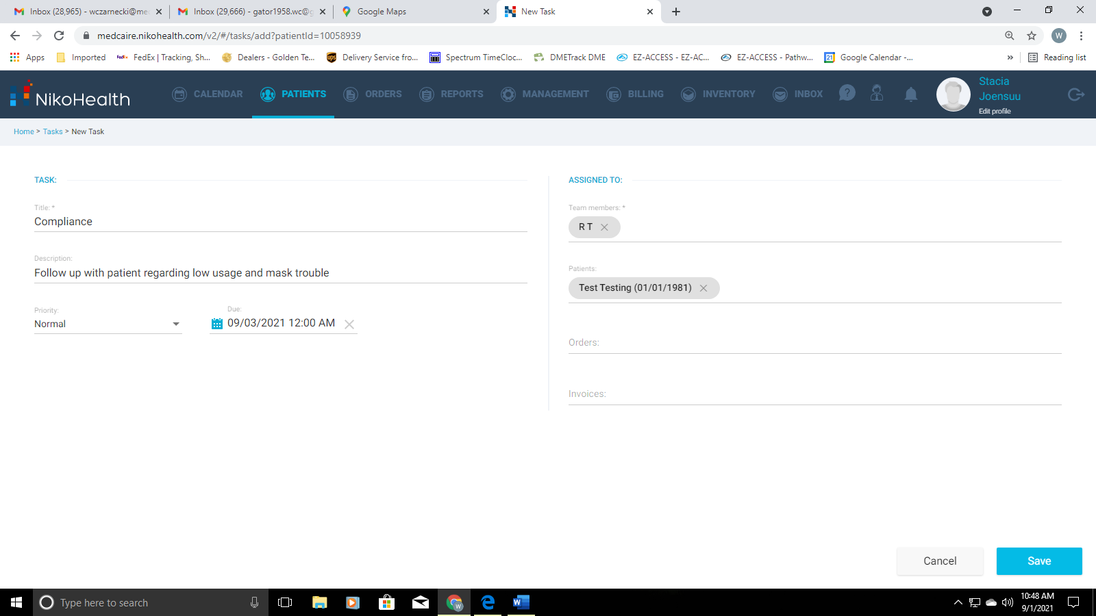

8- This is your created Task after being saved. The “Blue hyperlink” of the patient’s name will take you back to the patient’s file if you need.
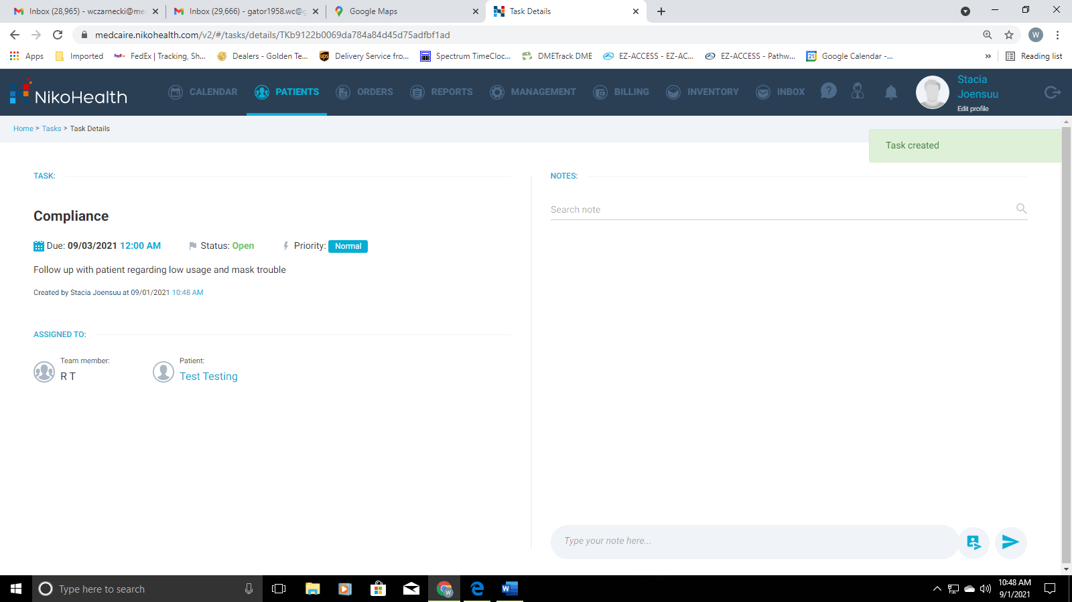

9- You can add notes to the Task while the task is in progress. Any user who is assigned to the task can make a note in the task. You will add the comment where it says “Type your note here” then hit the “Blue Arrow” to submit the comment. Keep in mind, These notes are not transferred into the patient’s file, they are only in the task.
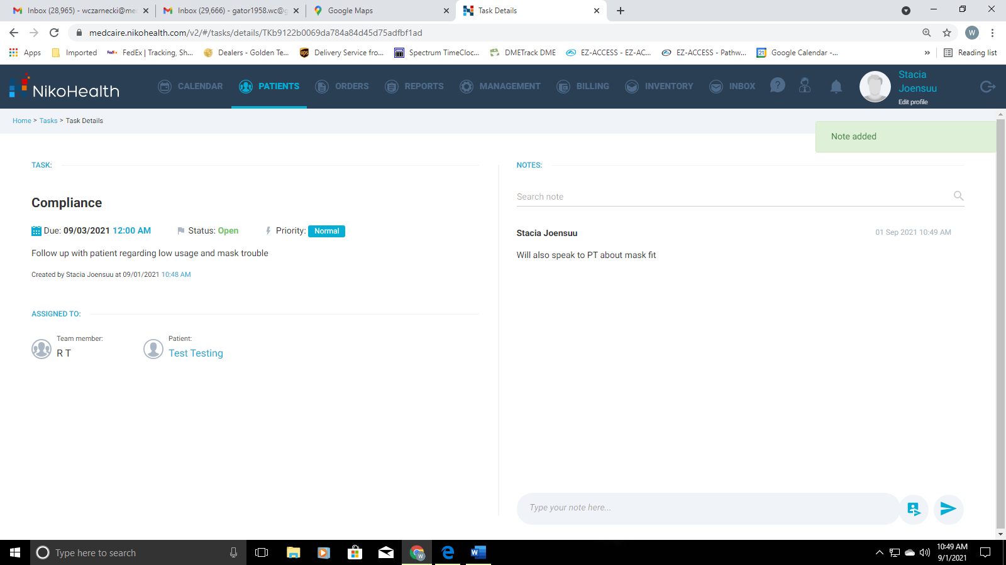

10- Using the "Blue Plus Sign" (Top Right Corner) you can now Complete the Task, Edit the Task, Delete the Task or Add a new Task
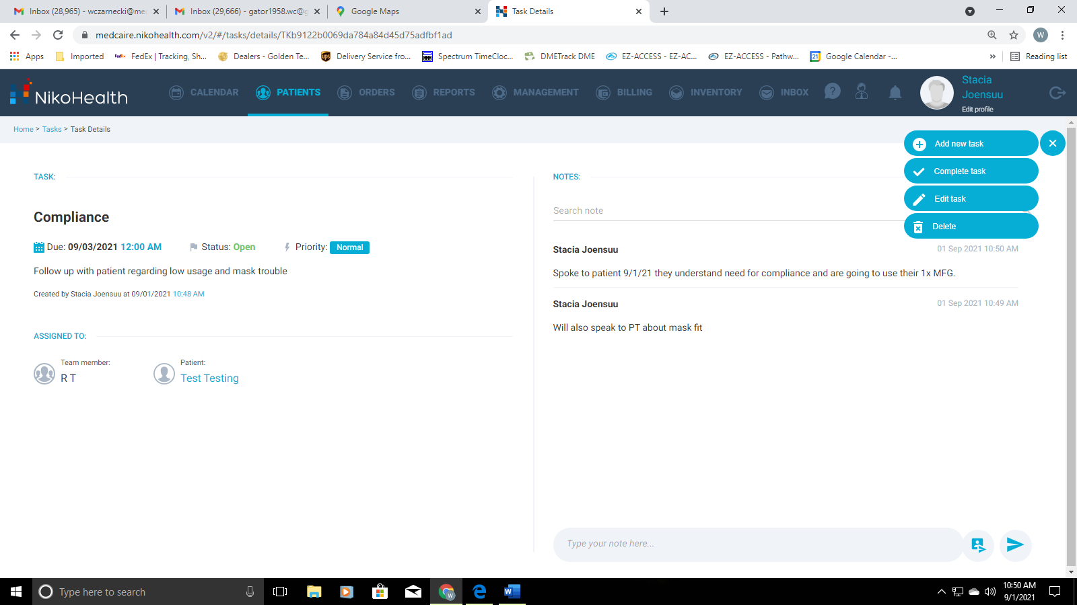

11- Once you’re done with a Task, using the "Blue Plus Sign" select "Complete Task" from the drop-down menu. You will be prompted with "Task Completed?" and you want to select "All Set" to complete the Task.
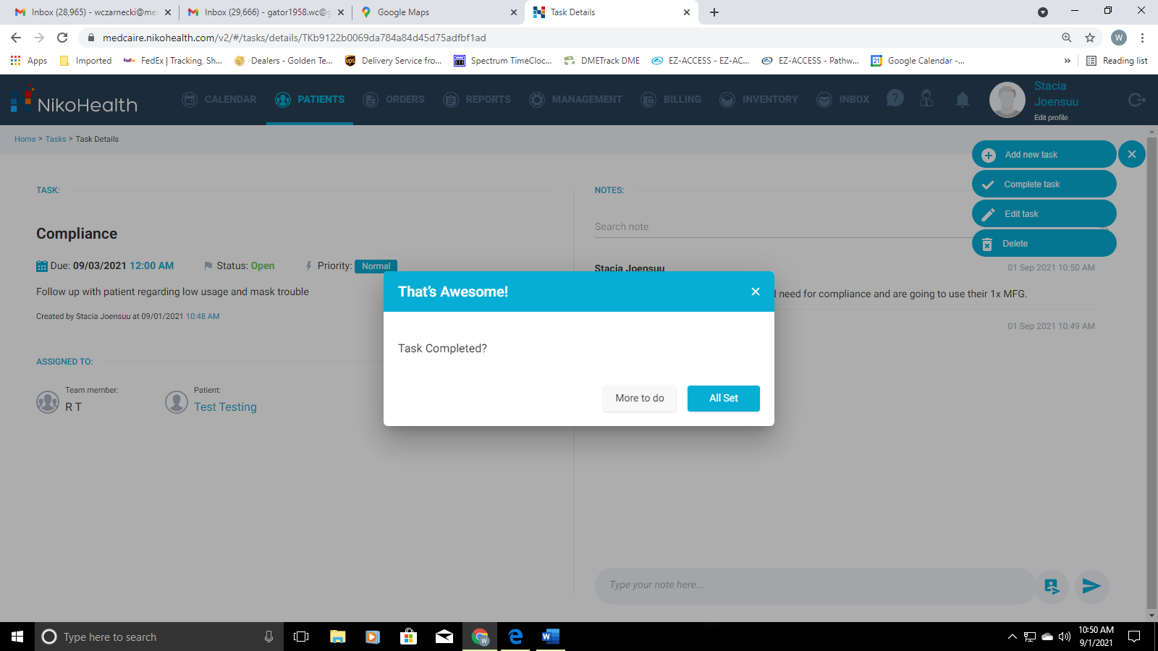

12- This is what a "Completed Task" should look like
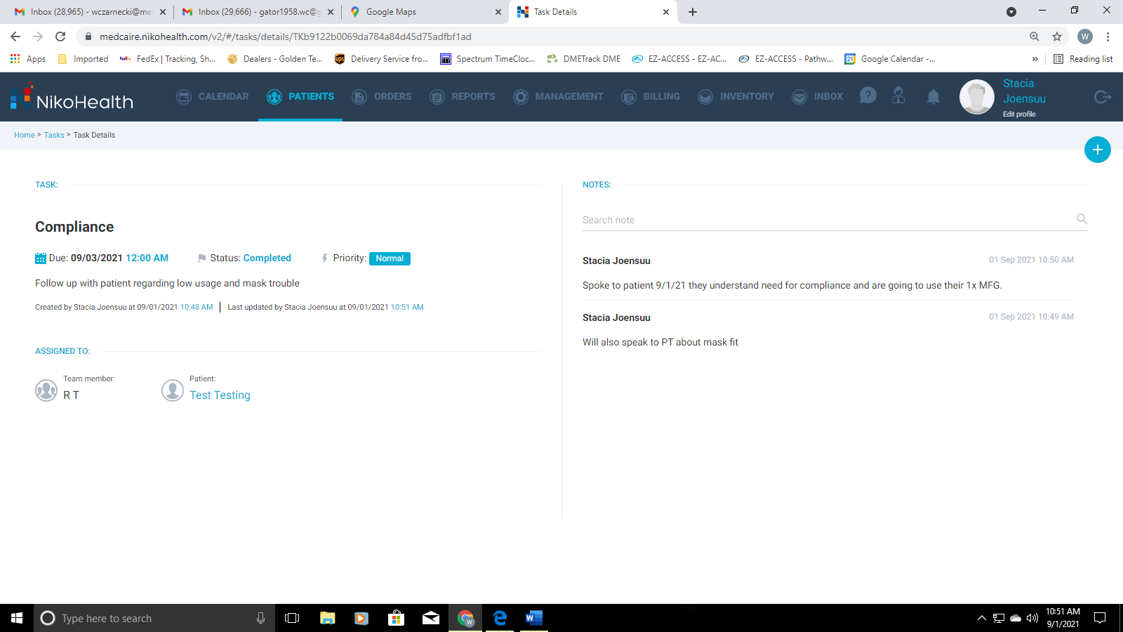

13- To Find you Tasks, From the Dashboard select "My Tasks" from the top menu
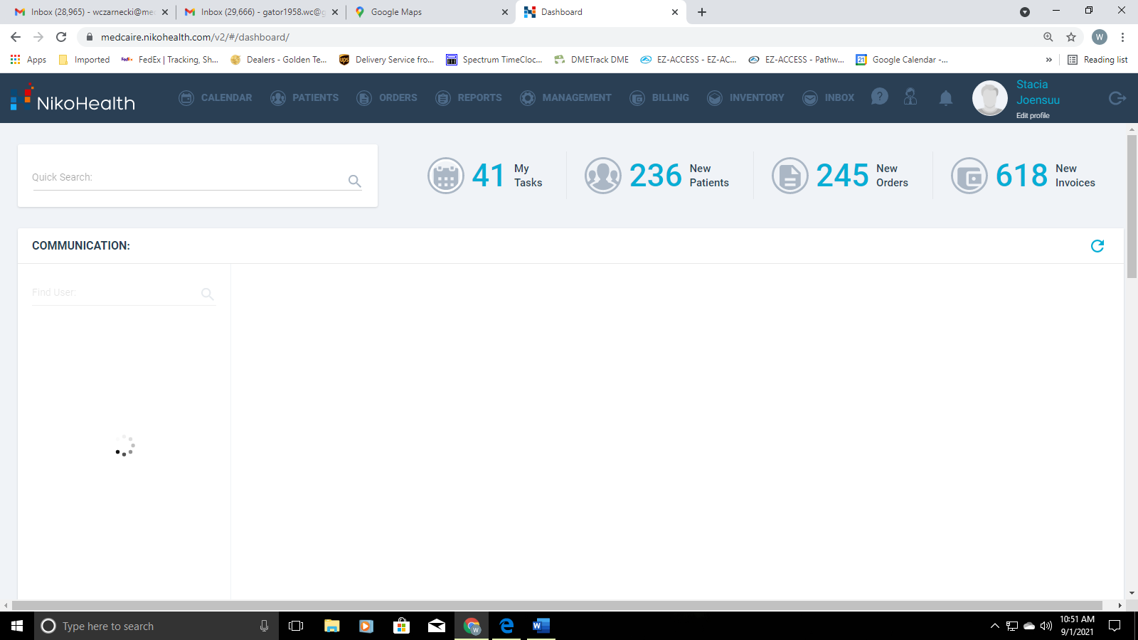

14- You can Search Tasks at the top of the screen using "Assigned to me" or "Created by me". You can also Filter your tasks, so you only see the active tasks using the "Status Field drop-down".
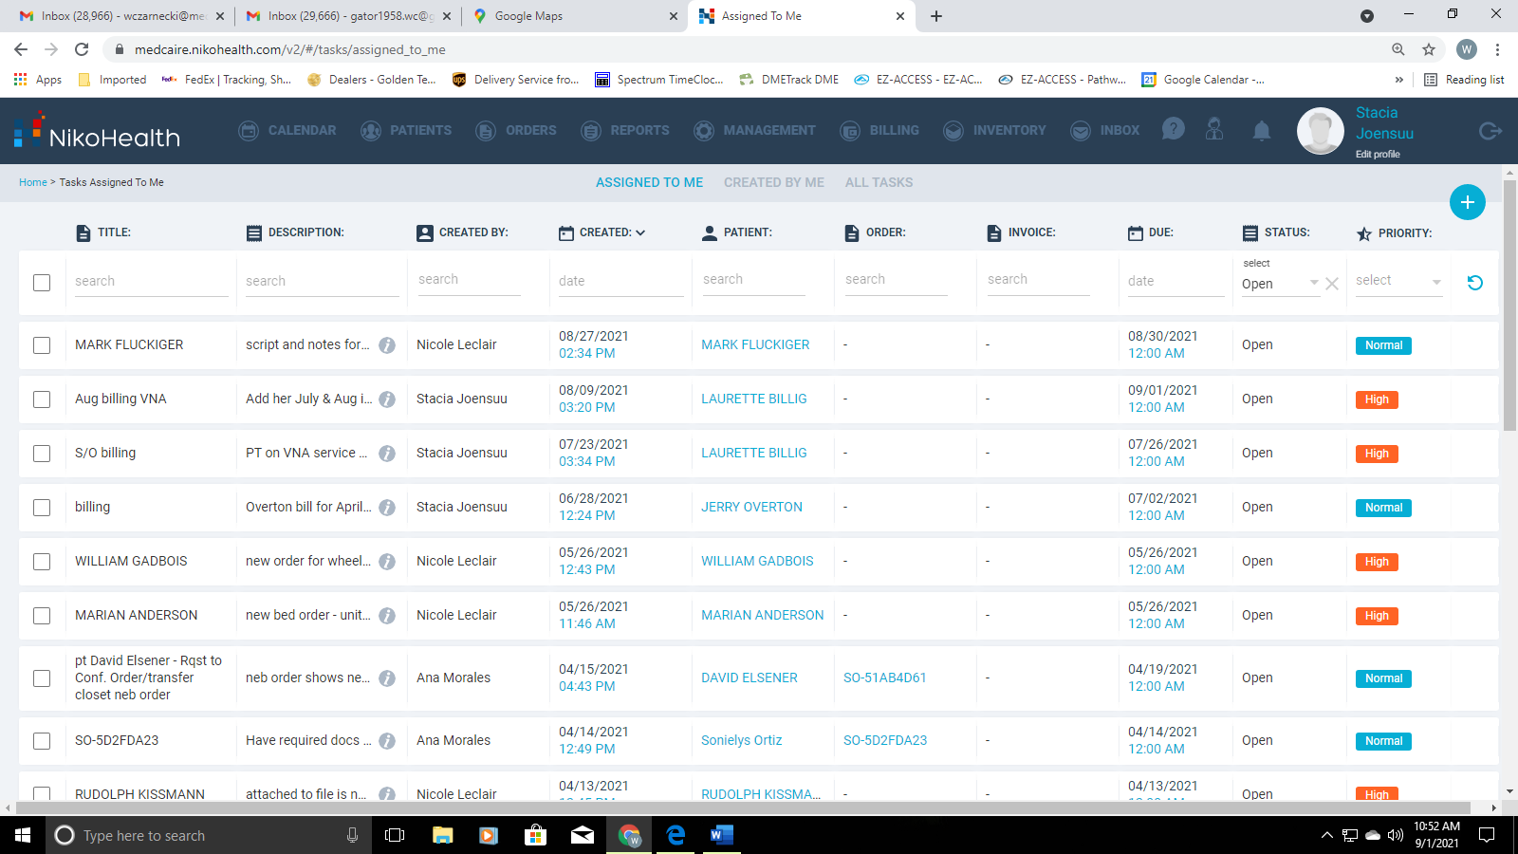

15- You can search individual patient tasks by enter the patient’s name, and select the patient you want to see the task(s) for.
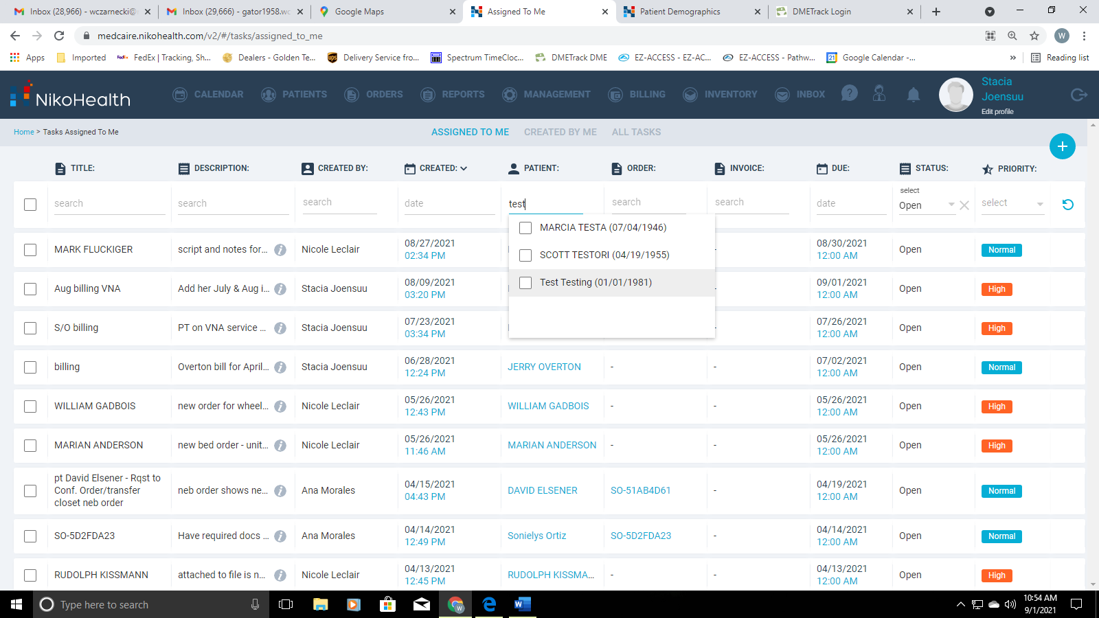
16- Select the Task you want to work, and you will be brought into the Task
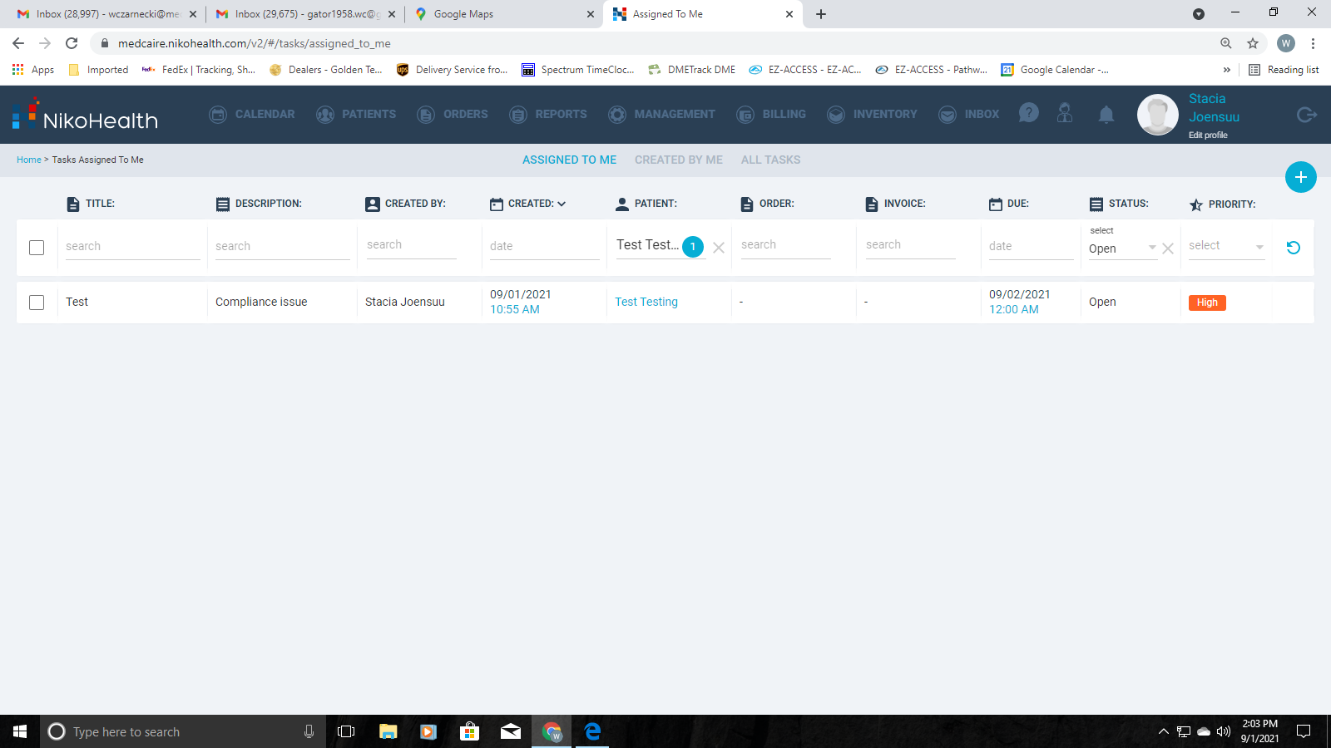

17- This is you’re created task and you can add a note, edit, delete, or complete the task from here.
